
G
HY/ACAK/1220A 04/11/2020
HALF YEARLY EXAMINATION (2020-21)
Subject: ACCOUNTANCY  Grade: XII |  | Max. Marks: 80  Time: 3 Hrs.
1. | c) Profit ₹28,000
2. | b) Shall be paid to firm
3 | c) ₹5,000 per month
4 | a)₹6,00,000
5 | - A's Capital A/c Dr. 10,000  To C's Capital A/c 10,000
6 | - 6:2:2
7 | - X only
8 | d)₹11,250
9 | b)4:5
10 | b)₹ 24,000 B ₹ 32,000 C ₹16,000
11 | c)When the business of the firm can’t be carried on except at a loss
12 | b)₹3,000
13 | a)Capital Reserve
14 | d))Purchase of fixed assets
15 | b)₹9 per share
16 | d)All of the above
17 | Share in profit
18 | Time and Sales
19 | Debited
20 | The portion of authorized capital which can be called up only on the liquidation of the company.
21 |  |  | 3
  Realization Account
  Particular | ₹ | Particular | ₹
  To Assets  To Bank(Liabilities paid)  To Bank(expenses of realization) | 5,00,000  1,00,000  5,000 | By liabilities  By Bank | 1,00,000  4,20,000
   |  | By Capital A/c  (Loss on realization) | 85,000
   | 6,05,000 |  | 6,05,000
22 |  |  | 3
  Particulars | Note No. | Amount
  - Equity & liabilities  - Shareholders Funds  - Share capital | 1 | 1,99,97,000
  Notes to accounts
  Particulars | ₹
  Authorised Capital  Issued Capital `2,00,00,000  Subscribed Capital:  Subscribed and fully paid up  1,99,900 shares @ 100 each  Not fully paid up  100 shares @ 100 each 10,000  Less: Calls in arrears 100 shares @ 30 3,000 | 7,00,00,000  2,00,00,000  1,99,90,000  7,000  1,99,97,000
23 | Profit at stake = 48000-24000-12000 = Rs.12000.  Amar = 1/3 – 2/10 = 4/30 gain  Akbar = 1/3 – 2/10 = 1/30 gain  Anthony = 1/3 – 5/10 = 5/30 sacrifice.  Journal Entry  Amar’s Capital A/c Dr 1,600  Akbar’s Capital A/c Dr 400  To Anthony’s Capital A/c 2000  (Being Adjustment entry passed) |  | 4
24 | Journal |  | 4
  Date | Particulars | l/f | Debit amount | Credit amount
  2019  1st April | Cash a/c -----------Dr  To Premium for Goodwill a/c  (Being C brings only a part of his share of goodwill) |  | 7,500 | 7,500
  1st April | Premium for Goodwill a/c-------Dr  C’s Current a/c --------Dr  To A’s Capital a/c  To B’s Capital a/c  (being premium distributed) |  | 7,500  2,500 | 6,000  4,000
  1st April | A’s capital a/c-------------Dr  B’s capital a/c-------------Dr  To Goodwill a/c  (being old goodwill written off in old ratio) |  | 15,000  10,000 | 25,000
25 | Working Note: *  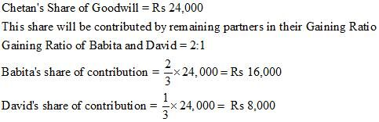  **Sales in the year 2018-19 = 4,00,000  Profit for year 2018-19 = 2,00,000 = 50% of Sales.  Therefore, Profit for the Period Apr 01 to 30th Sep = 50% of Sales of the same period  Share of Profit to be divided = 50% of Rs 1,20,000 = Rs 60,000  Chetan’s Share of Profit = 1/4th of Rs 60,000 = Rs 15,000  Journal entries:  Babita’s Capital a/c-------------Dr 16,000  David’s capital a/c---------------Dr 8,000  To Chetan’s capital a/c 24,000  Profit & Loss Suspense a/c-----------Dr 15,000  To Chetan’s capital a/c 15,000 |  | 4
26 | 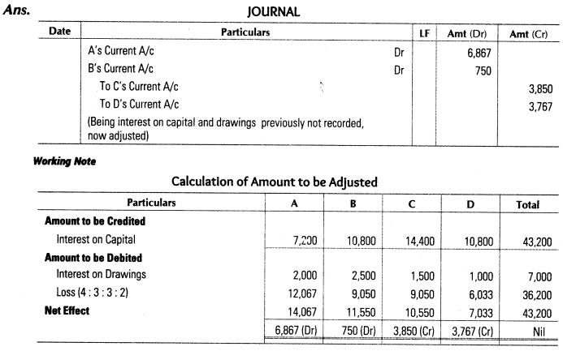 |  | 4
27 | Ans.  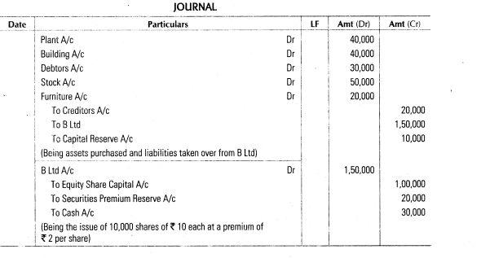 |  | 4
28 |  |  | 6
  Profit & Loss Appropriation Account
  To Salary | 6,000 | By P& L a/c | 50,000
  To Interest on capital
  A | 3,000
  B | 3,000
  To Profit transfd to
  A | 19,000
  B | 19,000
   | 50,000 |  | 50,000
  Partners' capital Account
  Particulars | A | B | Particulars | A | B
  To drawings | 15,000 | 20,000 | By Balance b/d | 50,000 | 100,000
  To Balance c/d | 63,000 | 102000 | By salary | 6,000
   |  |  | By interest | 3,000 | 3,000
   |  |  | By P&L Appropriation | 19,000 | 19,000
   | 78,000 | 122,000 |  | 78,000 | 122,000
29 | Journal |  | 6
  Date | Particulars | L.F. | (Rs.) | (Rs.)
  (a) | Realisation A/c |  | 12,000 | ……
   | To Bank A/c  (Being bank loan discharged) |  | …… | 12,000
  (b) | Realisation A/c |  | 400 | ….
   | To A’s Capital A/c  (Being commission to A credited to A’s Capital Account) |  | …. | 400
  (c) | A’s Capital A/c |  | 20,000 | …
   | B’s Capital A/c |  | 8,000 | ….
   | To Deferred Advertisement Expenditure A/c  (Being the deleted advertisement expenditure written off by debiting Partner’s Capital Account in Ratio 5:2, i.e. Profit Sharing Ratio) |  | …. | 28,000
  (d) | B’s Capital A/c |  | 1,200 | …
   | To Realisation A/c  (Being Stock taken over by B at Rs. 1,200 at agreed value) |  | …. | 1,200
  (e) | Bank A/c |  | 7,000 | ….
   | To Realisation A/c  (Being unrecorded computer sold for Rs. 7,000) |  | …. | 7,000
  (f) | Realisation A/c |  | 2,000 | ….
   | To Bank A/c  (Being outstanding bill paid for repairs) |  | …. | 2,000
30 |  |  | 6
  Revaluation Account
  Particulars | Amount | Particulars | Amount
  Stock | 2000 | Building | 12000
  Legal charges payable | 1800 | Provision for DD | 200
  Profit  X 3500  Y 2800  Z 2100 | 8400
  Total | 12200 | Total | 12200
  Capital Account
   | X | Y | Z |  | X | Y | Z
  Y | 10000 |  | 6000 | Bal b/d | 60000 | 48000 | 36000
  Y’s Loan |  | 40000 |  | Revaluation | 3500 | 2800 | 2100
  Cash |  | 26800 |  | X |  | 10000
  Bal c/d | 53500 |  | 32100 | Z |  | 6000
   | 63500 | 66800 | 38100 |  | 63500 | 66800 | 38100
31 |  |  | 8
  Dr. REVALUATION ACCOUNT Cr.
  Particulars  To Building  To Provision for BD  To Stock  To Furniture  To O/s Salary | 6,000  500  3,000  48,000  6,500 | Particulars  By Loss  R 38,400  S 25,600
   | 64,000 |  | 64,000
  Dr. Partners’ Capital Account Cr.
  Particulars | R | S | T | Particulars | R | S | T
  To Goodwill | 12,000 | 8,000 |  | By Balance c/d | 1,50,000 | 50,000
  To Revaluation A/c | 38,400 | 25,600 |  | By Reserve | 6,000 | 4,000
   |  |  |  | By P & L | 18,000 | 12,000
  To Balance c/d | 132600 | 53400 |  | By Bank |  |  | 40,000
   |  |  |  | By Premium | 9,000 | 21,000
   | 1,83,000 | 87,000 | 40,000 |  | 1,83,000 | 87,000 | 40,000
32 | Journal |  | 8
  Date | Particuars | L.F. | Debit | Credit
   | Bank a/c---------------Dr  To Equity share application a/c |  | 3,60,000 | 2,60,000
   | Equity share application a/c-----Dr  To equity share capital a/c  To equity share allotment a/c  To Bank a/c |  | 3,60,000 | 3,00,000  42,000  18,000
   | Equity share allotment a/c------dr  To equity share capital a/c  To SPR a/c |  | 5,00,000 | 2,00,000  3,00,000
   | Bank a/c---------------------Dr  To equity share allotment a/c |  | 4,58,000 | 4,58,000
   | Equity share first call a/c-------Dr  To equity share capital a/c |  | 3,00,000 | 3,00,000
   | Bank a/c------------------------Dr  Calls in arrears a/c------------Dr  To equity share first call a/c |  | 2,95,500  4,500 | 3,00,000
   | Equity share final call a/c--------dr  To equity share capital a/c |  | 2,00,000 | 2,00,000
   | Bank a/c------------------------Dr  Calls in arrears a/c------------Dr  To equity share final call a/c |  | 1,97,000 | 1,97,000
   | Equity share capital a/c-------dr  To Forfeited shares a/c  To Calls in arrears a/c |  | 15,000 | 7,500  7,500
   | Bank a/c------------------------dr  Forfeited shares a/c-----------dr  To equity share capital a/c |  | 8,000  2,000 | 10,000
   | Forfeited shares a/c-----------Dr  To capital Reserve a/c |  | 3,000 | 3,000
***

